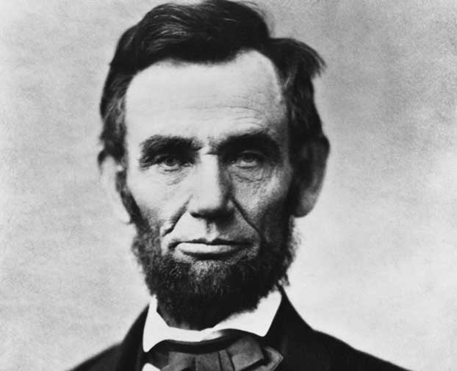
Self Portrait of Abraham Lincoln

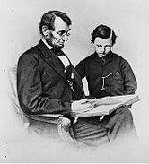
1864 photo of President Lincoln with youngest son, Tad

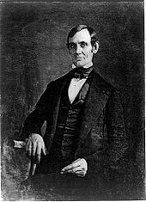

Lincoln in his late 30s – photo taken by one of Lincoln's law students around 1846

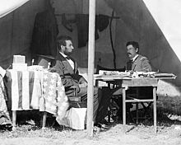

Lincoln and McClellan after the Battle of Antietam

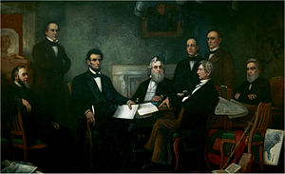

Lincoln presents the first draft of the Emancipation Proclamation to his cabinet.

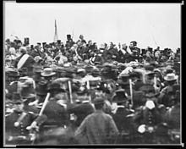

The only confirmed photo of Abraham Lincoln at Gettysburg.

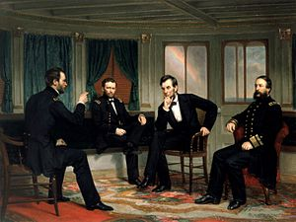

President Lincoln (center right) with, from left, Generals Sherman, Grant and Admiral Porter

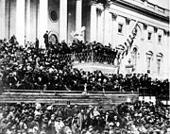
Lincoln's second inaugural address in 1865 at the almost completed Capitol building

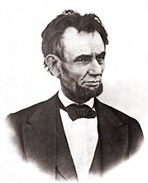

The last high-quality photograph of Lincoln was taken March 1865.

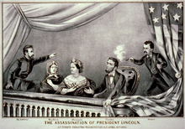

Shown in the presidential booth of Ford's Theatre right before his assassination

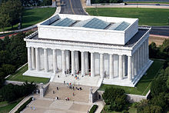

Lincoln Memorial in Washington, D.C.

